**HR DATA ANALYST QUERIES**

**KPI’s**

1. **Employee Count**

select sum(employee_count) as employee_count from hrdata

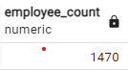

1. **Employee Count (Edu. - High School)**

select sum(employee_count) as employee_count from hrdata

where education = 'High School'

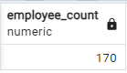

1. **Employee Count (Dep. – R&D)**

select sum(employee_count) as employee_count from hrdata

where department = 'R&D'

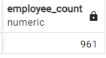

1. **Employee Count (Edu. - Medical)**

select sum(employee_count) as employee_count from hrdata

where education_field = 'Medical'

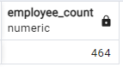

1. **Attrition Count**

select count(attrition) as Attrition_Count from hrdata

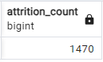

1. **Attrition Count (Yes)**

select count(attrition) as Attrition_Count from hrdata

where attrition = 'Yes'

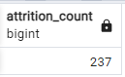

1. **Attrition Count (Yes & Doctoral Degree)**

select count(attrition) as Attrition_Count from hrdata

where attrition = 'Yes' and education = 'Doctoral Degree'

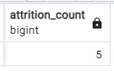

1. **Attrition Count (Yes & R&D)**

select count(attrition) as Attrition_Count from hrdata

where attrition = 'Yes' and department = 'R&D'

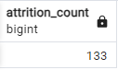

1. **Attrition Count (Y, R&D, Medical)**

select count(attrition) as Attrition_Count from hrdata where attrition = 'Yes' and department = 'R&D' and education_field = 'Medical'

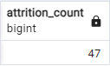

1. **Attrition Count (Y, R&D, Medical, High Scool)**

select count(attrition) as Attrition_Count from hrdata where attrition = 'Yes' and department = 'R&D' and education_field = 'Medical' and education = 'High School'



1. **Attrition Rate**

select round(((select count(attrition) from hrdata where attrition = 'Yes') / sum(employee_count))*100,2) as attrion_rate from hrdata

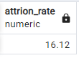

1. **Attrition Rate**

select round(((select count(attrition) from hrdata where attrition = 'Yes' where department = 'Sales') /

sum(employee_count))*100,2) as attrion_rate from hrdata where department = 'Sales'

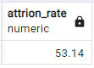

1. **Active Employee**

Select sum(employee_count) - (select count(attrition)from hrdata where attrition = 'Yes')

as active_emp from hrdata

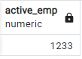

1. **Active Employee (Male)**

Select sum(employee_count) - (select count(attrition)from hrdata where attrition = 'Yes')

as active_emp from hrdata where gender = 'Male'

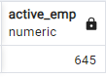

1. **Active Employee (Male)**

Select sum(employee_count) - (select count(attrition)from hrdata where attrition = 'Yes' and gender = 'Male') as active_emp from hrdata where gender = 'Male'

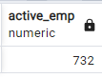

1. **Average Age**

select round(avg(age),0) as Avg_age from hrdata

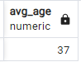

1. **Attrition By Gender**

select gender, count(attrition) from hrdata where attrition = 'Yes' group by gender

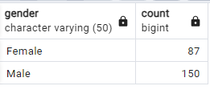

1. **Attrition by High School**

select gender, count(attrition) from hrdata where attrition = 'Yes' and education = 'High School'

group by gender order by count(attrition) desc

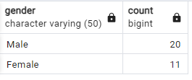

1. **Attrition by Department**

select department, count(attrition) from hrdata

where attrition = 'Yes'

group by department

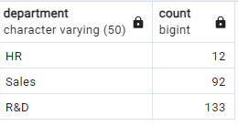

1. **Attrition by Department**

select department, count(attrition),

round ((cast(count (attrition) as Numeric)

/ (select count(attrition) from hrdata where attrition = 'Yes' ))*100,2) as pct

from hrdata

where attrition = 'Yes'

group by department

order by count(attrition) desc

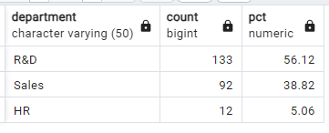

1. **No of Employee by age group**

select age, sum(employee_count) from hrdata

where department = 'R&D'

group by age

order by age

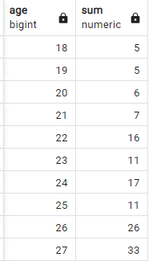

1. **Education field wise attrition**

select education_field, count(attrition) from hrdata

where attrition = 'Yes'

group by education_field

order by count(attrition)

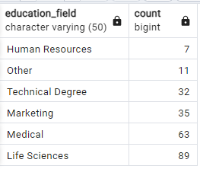

1. **Attrition Rate by gender for different age group**

select age_band, gender, count(attrition),

round((cast(count(attrition) as numeric) /

(select count(attrition) from hrdata where attrition = 'Yes'))*100,2) as pct

from hrdata

where attrition = 'Yes'

group by age_band, gender

order by age_band, gender

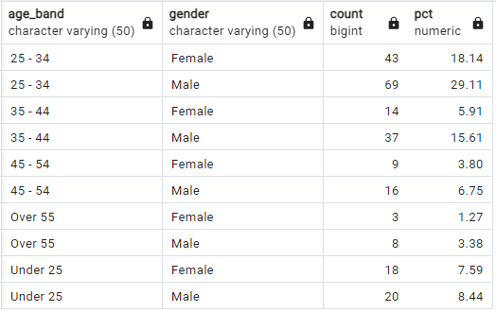

1. **Job satisfaction rating**

**SELECT * FROM**

**crosstab('SELECT job_role, job_satisfaction, sum(employee_count)**

**FROM hrdata**

**GROUP BY job_role, job_satisfaction**

**ORDER BY job_role, job_satisfaction'**

**) AS ct(job_role varchar(50), one numeric, two numeric, three numeric, four numeric)**

**ORDER BY job_role;**

create extension if not exists tablefunc;

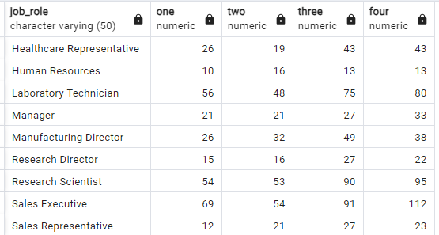

1. **No of Employee By age group**

select age_band, gender, sum(employee_count) from hrdata

group by age_band, gender

order by age_band, gender desc

